Data Structures and Algorithms
Exercise 7: Financial Forecasting
FinancialForecastOptimized.java:
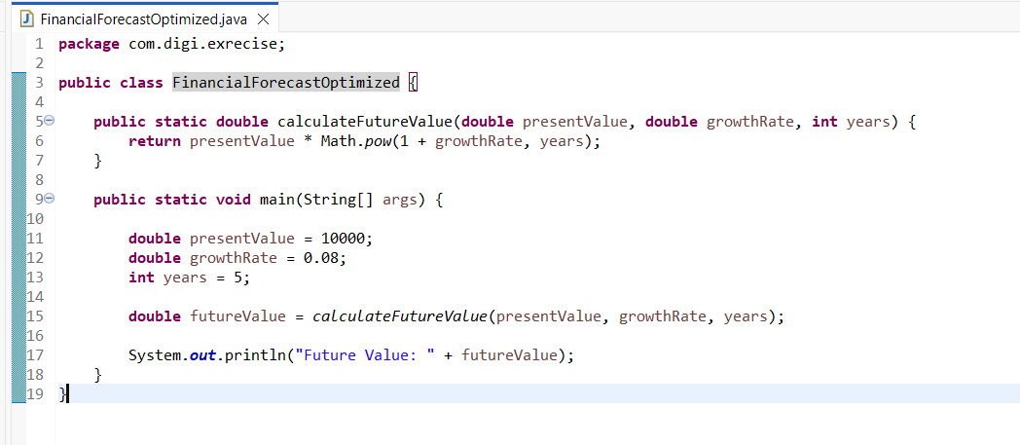
Output:
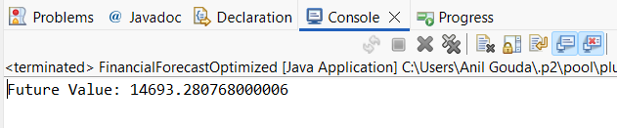
Analysis:
Time Complexity = O(1)
A simple recursive solution may perform many unnecessary function calls, which increases execution time and uses more memory because each recursive call is stored in the call stack. This can become inefficient when the number of recursive calls is large.
Optimization improves execution speed, reduces memory usage by avoiding a deep recursion stack, makes the program more efficient and scalable for larger inputs.

